

**Group Meeting #3**

The meeting of TeamSix has decided at FPT University at 20th March 2021.

**Attend present**

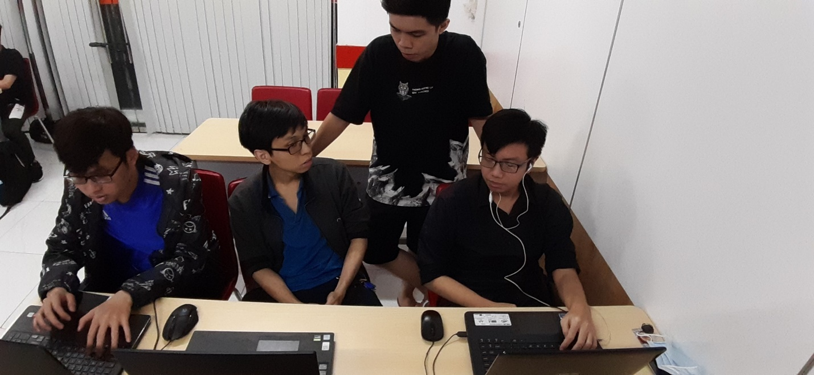

**There is 5 members in meeting:**

Pham The Phi

Hoang Khanh Son

Nguyen Hoang Nhan

Trinh Huynh Duc

Pham Tuan Kiet(There was urgent issue so he left early)

**Member Not Attendance**

Tong Dam Thang Long

**Report about**

**Test the function login, closure day, the day update and design website.**

**Time Meeting**

An initial team discussion about the project was held on 20th March, 2021 at 7h00.

**Approve comments during the meeting**

The function work well and the design need more developmental.

**Unfinished Work**

Follow up project.

**Next Work**

Work will hold at the next meeting at 27th March 2021.

**Work progress**

Fast.